Meeting memo (ISZE_ISZJ lubricant business MTG)
Date: 23rd February 2026
Attendee: ISZE – Masumi Hayakawa, Hadewijch Tibos, Jerome Van Der Pluym, Koen Matheussen
IML – Ryusuke Tanaka, Takayoshi Suzuki

ISZE and ISZJ agreed with proceed with the investigation of centralized purchasing of lubricants in Europe. It is important to collect large amount (at least 300-500KL/year) and current procurement price for bidding, but so is the schedule. We would like to confirm the intention of DLR to participate in, first. After discussion, tentatively we nominated 9 DBs with priority.
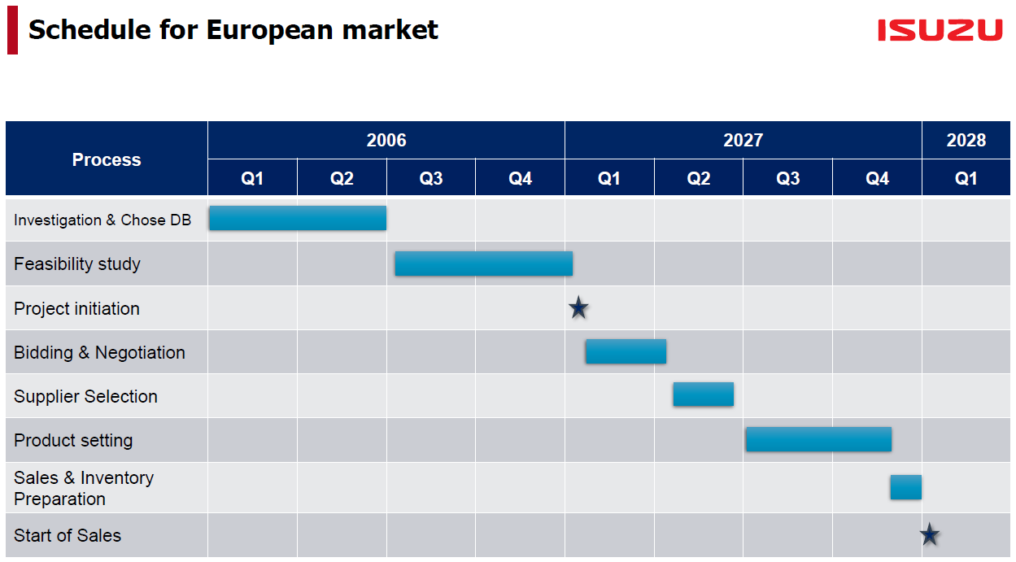

- Actions and Schedule for Investigation & Choose DBs
- tentative priority DBs
- UK(ITUK, IUK), Israel(UTI, UMI), Portugal(I-motors), Irland(Isuzu Ireland), Germany(ISD)
Sweden(IM Nordic), Norway(RSA). * Belgium(IBX): checking the situation
- ISZE collects the information and questionnaire by June.
- ISZE and ISZJ prioritize the market based on the 2) information/situation.

- Next Meeting
- follow up web MTG on 23rd Mar. (ISZE Hayakawa san sent Teams MTG invitation)
- ISZE checks with DBs about questions and unclear information raised in the MTG
- ISZE sends the questionnaire to all DBs to collect information.
- ISZE would share the feedback of above items with us.

-END-

